**Перший рівень** — відпрацюй навички на базовому рівні.

1. Створи високорівневий тест-кейс для перевірки функціоналу мобільного застосунка (Монобанк).

| № | Назва | Пріоритет | Передумови | Кроки | Очикуваний результат | Фактичний результат | Статус | Сервер |
| --- | --- | --- | --- | --- | --- | --- | --- | --- |
| 1 | Registration new user | High | the mobile app is installed on the Phone | 1. Enter mobile phone  2. Enter sms-code  3. Click Next  4. Choose variant of document  5. Scan document  6. Scan identification code (IC)  7. Check your IC  8. Enter your address  9. Add your email  10. Choose your work status  11. Click Next  12. Click Next  13. Click Begin  14. Click Next  15. Put your signature  16. Click Next  17. Click Call to operator  18. Click Finish | User should be registered |  |  | QA |

2. Створи 3 низькорівневі тест-кейси на основі високорівневого.

| № | Назва | Пріоритет | Передумови | Кроки | Очикуваний результат | Фактичний результат | Статус | Сервер |
| --- | --- | --- | --- | --- | --- | --- | --- | --- |
| 1 | Registration new user - filing documents | High | The mobile app is installed on the Phone. The Phone number was entered and the code was fielded in app | 1. Click Next  **2**. Choose Passport old version  **3**. Click Take a photo  **4**. Allow the use of the camera  **5**. Take a photo of 1st page of your Passport  **6**. Click Next  **7**. Click Take a photo  **8**. Take a photo of 2-3 pages of your Passport  **9.** Click Next  **10**. Click Take a photo  **11**. Take a photo of 4-5 pages of your Passport  **12**. Click Next  **13**. Click Take a photo  **14**. Take a photo of 6-7 pages of your Passport  **15**. Click Next  **16**. Click Take a photo  **17**. Take a photo of identification code (IC)  **18**. Click Next  **19**. Check your identification code (IC)  **20**. Click Next | **1**. Opening page with four variants how to registrate  **2**. Opening page with asking to open 1st page as on the picture  **3**. Opening request permission to use the camera  **4**. Opening scan process of 1st page  **5**. You can see the result of scan  **6.** Opening page with asking to open 2-3 pages as on the picture  **7.** Opening scan process of 2-3 pages  **8**. You can see the result of scan  **9**. Opening page with asking to open 4-5 pages as on the picture  **10**. Opening scan process of 4-5 pages  **11**. You can see the result of scan  **12**. Opening page with asking to open 6-7 pages as on the picture  **13**. Opening scan process of 6-7 pages  **14**. You can see the result of scan  **15.** Opening page with asking to open Identification Code (IC) as on the picture  **16**. Opening scan process of IC page  **17**. You can see the result of scan  **18**. Opening page with the Check of number your IC and keyboard to change it in case  **19**. The number should be the same  **20**. The fielding of documents is ended |  |  | QA |

| № | Назва | Пріоритет | Передумови | Кроки | Очикуваний результат | Фактичний результат | Статус | Сервер |
| --- | --- | --- | --- | --- | --- | --- | --- | --- |
| 2 | Registration new user - filing address documents | High | The mobile app is installed on the Phone. The user filled all document's steps with the scan | **1**. Write the City of registration and choose in autocomplete city  **2**. Write the street of registration and choose in autocomplete name of the street  **3.** Write the House number of registration  **4.** Click Next  **5**. Enter valid email  **6**. Click Next | **1**. Field City is filled  **2**. Field Street is filled  **3.** Field House is filled  **4**. Opening page with asking to enter email  **5**. Field email is filled  **6**. Opening page with massage that all documents are received |  |  | QA |

| № | Назва | Пріоритет | Передумови | Кроки | Очикуваний результат | Фактичний результат | Статус | Сервер |
| --- | --- | --- | --- | --- | --- | --- | --- | --- |
| 3 | Registration new user - filling work information | High | The mobile app is installed on the Phone. The user filled all document's steps | **1**. Choose your Social Status  **2.** Choose official position  **3**. Write the name of the company  **4**. Click Next  **5**. Choose work experience  **6**. Choose the size of salary  **7**. Click Next | **1**. Choosing maternity leave  **2**. opening page with field for writing the name of the company  **3**. The field is filled  **4**. Opening page with variants of work experience  **5**. Opening page with variants of size of the salary  **6**. The size of salary is chosen  **7.** Opening page with massage that your data is accepted |  |  | QA |

**Другий рівень** — детальніше заглибся в практику.

1. Виконай завдання попереднього рівня.

2. Проестимуй, скільки часу знадобиться для виконання тест-кейсів з попереднього завдання.

1-й тест-кейс - 5 хвилин

2-1 тест-кейс - 3 хвилини

3-1 тест-кейс - 2 хвилини

3. Для оцінки використай як мінімум 2 техніки (наприклад, WBS та трьохточкову естимацію).

|  | WBS (Хв) | 3 points (Хв) |
| --- | --- | --- |
| 1-й тест-кейс | seconds  1 10  2 10  3 10  4 10  5 30  6 10  7 10  8 30  9 10  10 10  11 30  12 10  13 10  14 30  15 10  16 10  17 50  18 10  19 20  20 10  6 хв | (10+5)/2=8 |
| 2-й тест-кейс | seconds  1 40  2 40  3 10  4 10  5 40  6 10  3 хв | (5+3)/2=4 |
| 3-й тест-кейс | seconds  1 30  2 20  3 40  4 10  5 10  6 20  7 10  3 хв | (4+3)/2=4 |

**Третій рівень** — різнобічно опануй тематику уроку.

Продовжуємо розвивати стартап для застосунка, який дозволяє обмінюватися фотографіями котиків. Команда тестувальників стартапу зростає разом із продуктом. Ви замислилися над створенням тестової стратегії.

Спробуй створити документ, який би відповідав потребам вашої команди ([темплейт додається](https://docs.google.com/document/d/1eJDrqN5TJuVqE6rULcFXZBejhSxeOkwl/edit?usp=sharing&ouid=115143950622232718184&rtpof=true&sd=true)).

CatShare

**Test Strategy**

**Revision History**

| Date | Version | Author | Description |
| --- | --- | --- | --- |
| 20.10.2022 | 1.0 | Shyshkova A. | Beginning of project CatShare |
| 26.10.2022 | 1.1 | Shyshkova A. | Amendments to the Test Strategy |
|  |  |  |  |
|  |  |  |  |

**Table of Contents**

**1. Scope 3**

**2. Test Approach 4**

**3. Test Environment 5**

**4. Testing Tools 6**

**5. Release Control 7**

**6. Risk Analysis 8**

**7. Review and Approvals 9**

# **Scope**

It defines parameters like

* Who will review the document? Product owner, Work Team
* Who will approve this document? Product owner
* Testing activities carried out with timelines. Testing mobile application

# **Test Approach**

It defines

* Process of testing
* Testing levels - Component testing, Integration testing, System testing, Acceptance testing
* Roles and responsibilities of each team member - Scrum master, 2 QA, 1 architect, 1 analyst, 4 programmers
* Types of Testing - Load testing, Performance testing.
* Testing approach & automation tool if applicable - no automation
* Adding new defects, re-testing, Defect triage, Regression Testing and test sign off in each Sprint

# **Test Environment**

* Define number of requirement and setup required for each environment. IntelliJ IDEA is one of the most popular integrated environments development (IDE) for Java programming. Android Studio – IDEA version, which includes a version of the Android SDK and additional graphics tools interfaces that simplify application development.
* Define backup of test data and restore strategy. Backup of test data will be every Sprint.

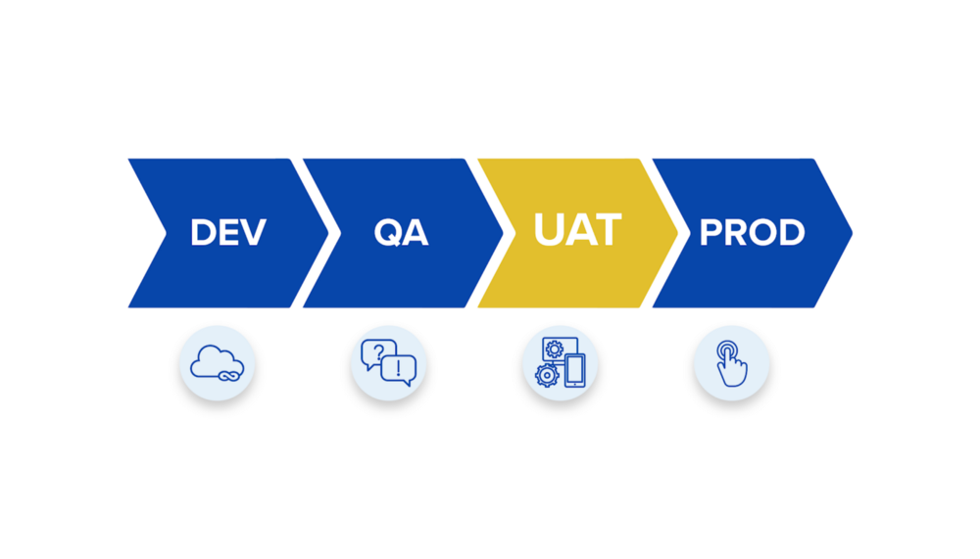

# **Testing Tools**

* Automation and Test management tools needed for test execution -
* Figure out number of open-source as well as commercial tools required, and determine how many users are supported on it and plan accordingly - Espresso, Robotium та Calabash.

# **Release Control**

* Release management plan with appropriate version history that will make sure test execution for all modification in that release

The release plan should be drawn up by the manager in close contact with the system architect, on the one hand, and on the other - during meaningful consultations with the customer.

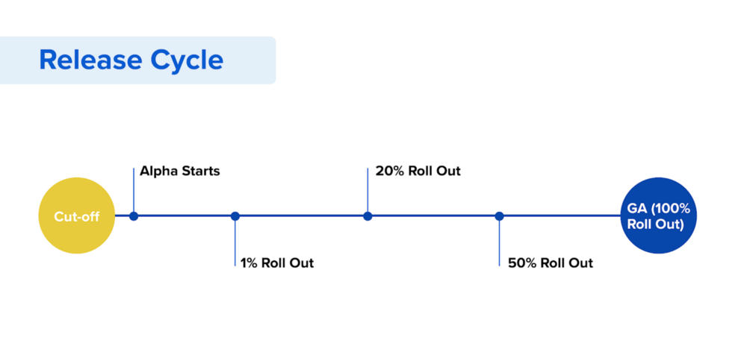

# **Risk Analysis**

* List all risks that you can estimate
* Give a clear plan to mitigate the risks also a contingency plan

Late release - you need to discuss all issues in a timely manner and fix bugs according to their level of criticality

# **Review and Approvals**

* All these activities are reviewed and sign off by the business team, project management, development team.
* Summary of review changes should be traced at the beginning of the document along with approved date, name, and comment